Quick Sort
Quicksort is based on the divide-and conquer approach and divides its input elements according to their value. A partition is an arrangement of the array’s elements so that all the elements to the left of some element A[s] are less than or equal to A[s], and all the elements to the right of A[s] are greater than or equal to it:
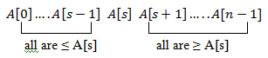

We can continue sorting the two subarrays to the left and to the right of A[s] independently (e.g., by the same method).

Quick sort picks one element as a pivot and shifts the pivot to the correct location in each iteration. By repositioning the pivot, the array is divided into two subarrays of equal or unequal size. The value of the pivot determines division. As a pivot, the first element can be chosen.
On each recursive call, quick sort does following:
- Function partition scans the array from left to right until an element greater than pivot is found.
- Scans the array from right to left until an element equal or smaller than pivot is found.
- After finding such elements,
    - If i ≤ j, then exchange A[i] and A[j].
    - If i > j, then exchange A[pivot] and A[j], which will split the list into two sub-
arrays. Solve them recursively.

Here is pseudocode of quicksort:

void quicksort(a, low, high)
{
if (low < high)
s = partition(a, low, high);
quicksort(a, low, s - 1);
quicksort(a, s + 1, high);
}

void partition(a, low, high)
{
p = a[low];
i=low+1;
j=high;
while (i>=j)
{
while (i<=j && a[j]>=p)
j=j-1;
while (i<=j && a[i]<=p)
i=i+1;
if (i<=j)
swap(a[i], a[j])
else
break;
}
swap(a[l], a[j]);
return j;
}

Time Complexity
Basic Operation:
The basic operation is the key comparison operation A[i] ≥ p andA[j]≤ P.

Worst Case Time Complexity:
In the worst case, all the splits will be skewed to the extreme: one of the two subarrays will be empty, while the size of the other will be just one less than the size of the subarray being partitioned. This situation will happen, in particular for increasing arrays. If A[0..n-1] is a strictly increasing array and if A[0] is used as the pivot, the left-to-right scan will stop on A[1] while the right-to-left scan will go all the way to reach A[0], indicating the split at position 0. So, after making n+1 comparisons to get to this partition and exchanging the pivot A[0] with itself, the algorithm will find itself with the strictly increasing array A[1..n-1] to sort.Thsi sort of strictly increasing arrays of diminishing sizes will continue until the last one A[n-2..n-1] has been processed. The total number of key comparisons made will be equal to
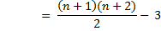
)
Best Case Time Complexity:
If all the split occurs in the middle and then the left and the right part will have same size.
The number of key comparisons in the best case will satisfy the recurrence
C_{best}(n) = 2C_{best}(n/2) + n for n > 1,
C_{best}(1) = 0

Put n=2^{k}
C_{best}(2^{k}) =2 C_{best}(2^{k}/2)+2^{k}
C_{best}(2^{k}) = 2 C_{best}(2^{k-1})+2^{k}
Now substitute C(2^{k-1}) = 2C(2^{k-2})+2^{k-1}
C_{best}(2^{k}) =2 [2C_{best}(2^{k-2})+2^{k-1}]+2^{k}
=2²C_{best}(2^{k-2})+2.2^{k-1}+2^{k}
=2²C_{best}(2^{k-2})+2^{k}+2^{k}
=2²C_{best}(2^{k-2})+2.2^{k}
Now substitute C(2^{k-2}) = 2C(2^{k-3})+2^{k-2}
=2²[2C_{best}(2^{k-3})+2^{k-2}]+2.2^{k}
=2³C_{best}(2^{k-3})+2².2^{k-2}+2.2^{k}
= 2³C_{best} (2^{k-3})+2^{k}+2.2^{k}
⁼ 2³C_{best} (2^{k-3})+3.2^{k}
Similarly, C_{best}(2^{k}) = 2⁴C_{best} (2^{k-4})+4.2^{k}
…
…
…
As a generalisation,
C_{best}(2^{k})= 2^{i}C_{best}(2^{k-i})+i.2^{k}
Sub i=k,
C_{best}(2^{k})= 2^{k}C_{best}(2^{k-k})+k.2^{k}
=2^{k}C_{best}(1)+k.2^{k} since C_{best}(1) = 0
=0+k.2^{k} (1)
Taking log on both sides for n=2^{k},
log₂n = log₂2^{k}
=k log₂2 log₂2 = 1
k = log₂n
Sub k = log₂n and 2^{k}=n in the equation (1)
C_{best}(n)=(log₂n).n
=n log₂n
C_{best}(n) = θ(n log₂n)
Hence the complexity is C_{best}(n) ϵ Ɵ(n log₂n)

Average Case Time Complexity:

Recurrance Equation:
C_{avg (n) =} C_{avg} (s) + C_{avg} (n-1-s)] for n>1

Initial Condition: C_{avg} (0) = 0 ; C_{avg} (1) = 0

Analysis:
Since C(s) = C(n-1-s) // position (n-1-s) is more or less equivalent to position s.
C(n) = ) + 2C(s)]

= )] +

= +
C(n) = (n+1) +

n C(n) = n(n+1) + 2 1
sub n = n-1 in 1
(n-1)C(n-1) = (n-1)(n-1+1) + 2 2
eqn 2 – eqn 1
(n-1)C(n-1) – nC(n) = (n-1)(n) + 2 - n(n+1) - 2
nC(n) = (n-1)C(n-1) – n² + n + n² + n + 2[ - ]
nC(n) = (n-1)C(n-1) + 2n + 2[C(n-1)]
nC(n) = (n+1)C(n-1) + 2n

Divide by n(n+1),
= + 3

Sub n = n-1 in eqn 3
= +

Sub n = n-2 in eqn 3
= +
.
.
= +
Backward Substitution:
= + +

= + + +
In General,

= + + +
Put i = n-1,
= + + . . . . . + +

= 0 + + . . . . . . + +

= 2[ + . . . . . . + + ]

= 2[]

= 2[ - 1/1 -1/2 ]

= 2[ - 3/2 ]
= 2 ln(n+1)
C(n) = (n+1) 2 ln(n+1)
= 2 n ln(n)
C(n) = 1.38 n log₂ n
Problem: Trace quick-sort for the data set A = {44, 22, 33, 77, 11, 55, 66}

Solution:

Step 1: Fix pivot point, low and high

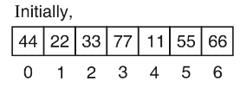
Step 2: A[low] = 22 and A[pivot] = 44
A[low] < A[pivot] ⇒ low = low + 1 = 1 + 1 = 2
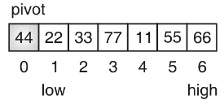
Step 3: A[low] = 33 and A[pivot] = 44
A[low] < A[pivot] ⇒ low = low + 1 = 2 + 1 = 3
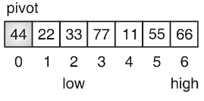
Step 4: A[low] = 77 and A[pivot] = 44
A[low] > A[pivot] ⇒ fix low
Now, check for high
A[high] = 66 and A[pivot] = 44
A[high > A[pivot] ⇒ high = high – 1 = 6 – 1 = 5
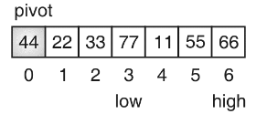
Step 5: A[high] = 55 and A[pivot] = 44
A[high] > A[pivot] ⇒ high = high – 1 = 5 – 1 = 4
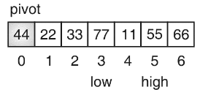
Step 6: A[high] = 11 and A[pivot] = 44
A[high] ≤ A[pivot] ⇒ fix high and perform swap
Here, low < high, so swap A[low] with A[high] and again start moving low pointer
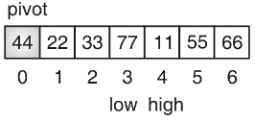
Step 7: A[low] = 11 and A[pivot] = 44
A[low] < A[pivot] ⇒ low = low + 1 = 3 + 1 = 4
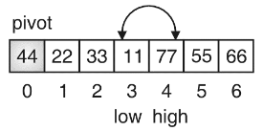
Step 8: A[low] = 77 and A[pivot] = 44
A[low] > A[pivot] ⇒ fix low
Now, check high
A[high] = 77 and A[pivot] = 44
A[high] > A[pivot] ⇒ high = high – 1 = 4 – 1 = 3
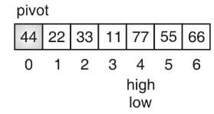
Step 9: A[high] = 11 and A[pivot] = 44
A[high] ≥ A[pivot] ⇒ fix high and perform swap
Here, low ≥ high so swap A[pivot] with A[high] divide list in two sublists and reset pointers. Recursively sort both the sublists.
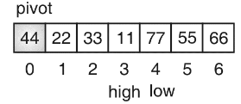
Step 10: Let us first sort the left sub-list
A[low] = 22 and A[pivot] = 11
A[low] > A[pivot], ⇒ so fix low
Now, check high pointer
A[high] = 33 and A[pivot] = 11
A[high] > A[pivot] ⇒ high = high – 1 = 2 – 1 = 1
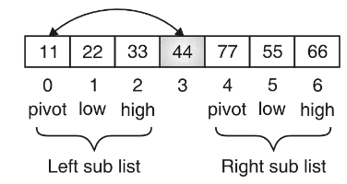
Step 11: A[high] = 22 and A[pivot] = 11
A[high] > A[pivot] ⇒ high = high – 1 = 1 – 1 = 0
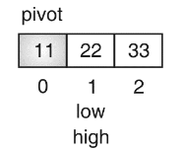
Step 12: A[high] = 11 and A[pivot] = 11
A[high] ≤ A[pivot] ⇒ so fix high and perform swap
Here, low ≥ high so swap A[pivot] with A[high], divide list in two sublists and reset pointers. Recursively sort both the sublists
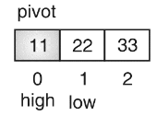
Step 13 : A[low] = 33 and A[pivot] = 22
A[low] > A[pivot] so fix low
Now, check high
A[high] = 33 and A[pivot] = 22
A[right] > A[pivot] ⇒ high = high – 1 = 2 – 1 = 1
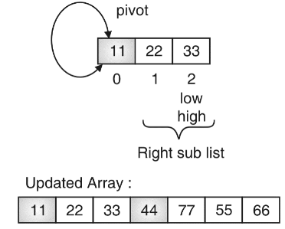
Step 14: A[high] = 22 and A[pivot] = 22
A[high] ≤ A[pivot], so fix high and perform a swap
Here, low ≥ high so swap A[pivot] with A[high], divide list in two sub-lists. Left sub-list has size zero and right sub-list has only one element {33}, so no further process is required.
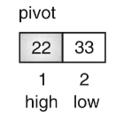
Step 15: Let us now sort the right sub-list of original array derived in step 9
A[low] = 55 and A[pivot] = 77
A[low] < A[pivot] ⇒ low = low + 1 = 5 + 1 = 6
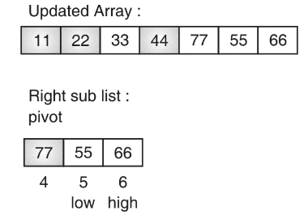
Step 16: A[low] = 66 and A[pivot] = 77
A[low] < A[pivot] ⇒ low = low + 1 = 6 + 1 = 7
low > high so stop,
Now, check for high
A[high] = 66 and A[pivot] = 77
A[high] < A[pivot], so fix high and perform swap
Here, low ≥ high so swap A[pivot] with A[high], divide list in two sub lists and reset pointers. Right sub list has size zero. So only left sub list needs to be sorted
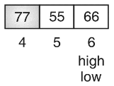
Step 17: A[low] = 55 and A[pivot] = 66
A[low] < A[pivot] ⇒ low = low + 1 = 5 + 1 = 6
low > high so stop,
Now, check for high
A[high] = 55 and A[pivot] = 66
A[high] < A[pivot], so fix high and perform swap
Here, low ≥ high so swap A[pivot] with A[high], divide list in two sub lists and reset pointers. Right sub list has size zero and right sub list is of size 1, so sorting is not required at all.
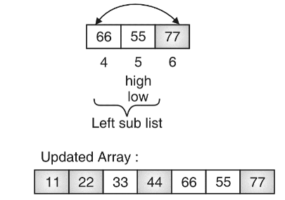
The final sorted array is:
